**KHYBER PAKHTUNKHWA HUMAN CAPITAL INVESTMENT PROJECT (kphcip)**

**Monitoring Report of Girls Community Schools (GCS)**

**District Swabi and Haripur**

**Visit Date:** 13 and 14 September 2023

**District:** Swabi and Haripur

**Visiting Team:**  Khizar Dawood (M&E Officer)

**Visit Objective:** Monitoring Visit of Girls Community School (GCS)

**Report Prepared By:** Khizar Dawood (M&E Officer)

The Elementary and Secondary Education Foundation (ESEF) is tasked to establish 400 GCS in the four selected project districts under KP-HCIP education. These centers aim to provide quality education to out-of-school children through purposefully designed schools to enable children to catch up a lost opportunity of getting education. The GCS under the project were established till Sep, 2023 at Peshawar (104), Nowshera (50), Haripur (115), and Swabi (96), with a focus on Afghan refugees’ children and the hosting communities. The centers operate in morning shift to facilitate the children.

**Objectives of the visit were:**

1. to assess the operational status of the GCS,
2. to verify the supplies provided under the project,
3. to take feedback from learners, facilitators, and the community in general about the GCS.

**On Sep 13, 2023, 01 GCS in District Swabi and on Sep 14 2023, 02 GCS were visited following;**

|  |  |  |  |  |  |  |
| --- | --- | --- | --- | --- | --- | --- |
| **Sr#** | **Date** | **District** | **Center Name** | **Total Learners Enrolled** | **Local Learners** | **Afghan Refugees** |
| 1 | Sep 13, 2023 | Swabi | GCS Bangzara | 47  (G=23, B=24) | 42  (G=20, B=22) | 05  (G=03, B=02) |
| 2 | Sep 14, 2023 | Haripur | GCS Sikandarpur | 40  (G=21, B=19) | 32  (G=17, B=15) | 08  (G=4, B=4) |
| 3 | Sep 14, 2023 | Haripur | GCS Dairy Sikandarpur | 43  (G=22, B=21) | 36  (G=19, B=17) | 07  (G=3, B=4) |
| **Total** | | | | **130**  **(G=66, B=64)** | **110**  **(G=56, B=54)** | **20**  **(G=10, B=10)** |

**Center-wise details are as follows;**

1. **GCS Bangzara-District Swabi; Dated: Sep 13, 2023**

|  |  |  |  |  |  |
| --- | --- | --- | --- | --- | --- |
| Total Learners Registered | Local Learners | Afghan Refugees | Withdrawal | Present at the time of visit | No. Of Facilitators |
| 47 | 42 | 05 | 00 | 37 | 01 |

**Key Findings:**

* GCS Bangzara situated in Tehsil Razar of District Swabi, Union Council Rasheed Garhi.
* GCS is located in the community provided place and has been operational since April 2023.
* The GCS is functioning during the morning shift from 07:30 am to 12:30 pm.
* Supplies of various items held to the visited GCS, including a teachers chairs, Matts, signboard, whiteboard, notebooks, stationary, teaching and learning material, water cooler, steel cupboard.
* GCS was comprised of 01 room, while additional room was also available for future expansion of the center. The center observed functional, having 47 learners (23 Girls and 24 Boys) registered; Out of them, 05 learners are Afghan Refugee (03-Girls, 02-Boys), while 42 Locals (20-Girls, 22-Boys) registered. Learner’s related information was verified from the enrolment register and attendance register at the center.
* The age range of the learners in the center was between 04 and 10 years.
* Female facilitator, Miss. Noreen Anjum was present in the center. She is a local community member, M.A qualified (fulfilling minimum qualification criteria of B.A).
* Miss. Noreen was having service agreement with ESEF. She also confirmed that the stipend has received of amount 63,333 PKR of 2.5 months (Mid-April to June 2023).
* Inside the center the required facilities like washrooms, drinking water electricity and boundary wall was available.
* For the community support and smooth operations of the center Village Education Committee (VEC) formation has held, total 07 members are a part of the committee, including 01 female & 06 male community members. Since the formation, a single meeting was held in which purpose, & the roles and responsibilities told to them.
* During the visit, Miss Noreen also mentioned that no government primary school exist inside or nearby the village, but one primary and middle school is available approx. 02 K.M away of the village Bangzara.
* As of the visit date, the teacher at GCS Bangzara have not received any training on GCS scope.
* Multi-grade learning methodology being adopted in the GCS, in which the learners of pre-school and primary (up to 5th class) are enrolled, which is in fact a challenging for the facilitator to maintain the learning needs and cover the topics of different subjects of different grades in a single room. Therefore, a need is observed to schedule robust training and capacity building activities for the facilitators to properly handle the learning needs of the children.
* In addition to the above, the daily subject planner along with the methodology (guideline) shall be developed and provided to the facilitators for their guidance.
* Feedback from one of the learner’s mother- Ammar also collected. She shared, *“I am very happy for my child and thankful to those who establish this center “GCS Bangzara” in our village. Because of this center, he is abled now to get education near to the house without going to the government school situated about 02 K.Ms at nearby village, which is not possible for him to manage at his own. I belief that he will complete his initial education here in the GCS till he becomes old enough to travel and attend the formal school”.*

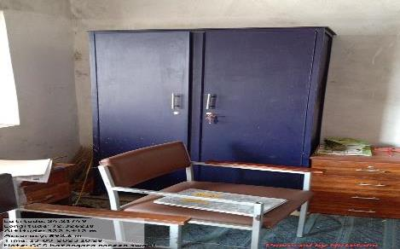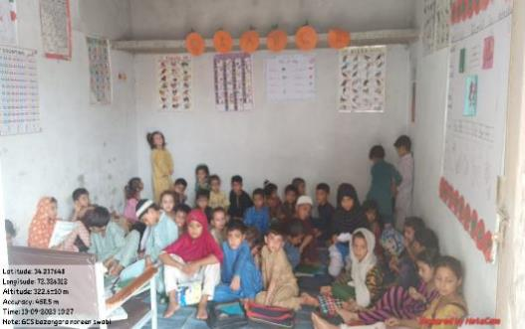

**Figure 6: View of provided Cupboard, Side drawer, Facilitator chairs**

**Figure 5: View of provided water cooler.**

**Figure 4: View of Signboards Outside at the street**

**Figure# 3: View of Signboards mounted at the GCS wall.**

**Figures# 1 & 2: View of learners at GCS Bangzara**

|  |
| --- |
| *Pictures* |

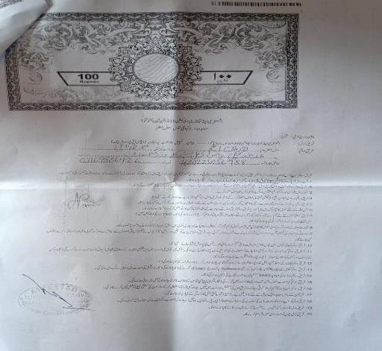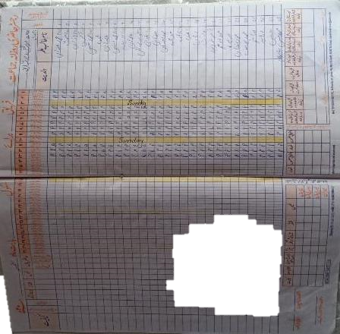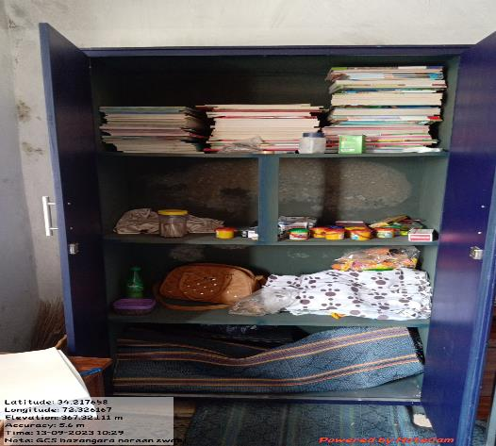

Figure 10: View of learner’s attendance maintained at GCS

Figure 8: View of provided Furniture

Figure 7: View of provided Learning material.

Figure 9: Signed Agreement of Facilitator

1. **GCS Sikandarpur-District Haripur; Dated: Sep 14, 2023**

|  |  |  |  |  |  |
| --- | --- | --- | --- | --- | --- |
| Total Learners Registered | Local Learners | Afghan Refugees | Withdrawal | Present at the time of visit | No. Of Facilitators |
| 40 | 32 | 08 | 01 | 37 | 01 |

**Key Findings:**

* GCS Sikandarpur is situated in Tehsil Haripur of District Haripur, Union Council Sikandarpur.
* GCS is established at facilitator’s owned house and operational since April 2023.
* The GCS is functioning during the morning shift from 07:30 am to 12:30 pm.
* Supplies of various items held to the visited GCS, including a teacher’s chairs, Matts, whiteboard, notebooks, stationary, teaching and learning material, water cooler, steel cupboard. While a signboard is provided on the day of visit. According to the facilitator, her brother received the signboard from the district office of ESEF (with due reason the signboards could not verified by the visiting team). In addition to these, the Learners and Facilitator attendance registers were not provided to them, but the facilitator has purchased the registers at her own and managed the attendance accordingly.
* The house where the GCS is established in comprised of 2 rooms; one is currently utilized as a GCS while another one could be used for future expansion.
* During the visit, the GCs was observed functional, having 40 learners (21 Girls and 19 Boys) registered; Out of them, 08 learners are Afghan Refugee (04-Girls, 04-Boys), while 32 Learners (17-Girls, 15-Boys) are local.
* The age range of the learners in the center was between 3.5 and 10 years.
* The center operates as a multigrade establishment, currently accommodating students from Prep, Nursery, and grades 1st, 3rd, 4th, and 5th.
* Female facilitator, Miss. Zartasha was present in the center. She is a local community member, B.A qualified (fulfilling the minimum qualification criteria of B.A). Apart form this, the facilitator shared details about her teaching experience that she used to teach and performing administrative role in her father’s school. The school level was middle and she taught there for more than 5 years, but after the marriage she left the teaching.
* Miss. Zartasha was having service agreement with ESEF. She also confirmed that the stipend has received of amount 55,000 PKR of 2 months (May and June 2023).
* Inside the center the required facilities like washrooms, drinking water electricity and boundary wall was available.
* For the community support and smooth operations of the center Village Education Committee (VEC) formation has held, total 07 members are a part of the committee, including 01 female & 06 male community members. Since the formation, not a single meeting was held, but facilitator shared that the meeting in 1st week of Oct, 2023 is scheduled.
* During the visit, the facilitator also mentioned that no government primary school exist inside or nearby the village, but Government Primary and Middle schools are situated at approx. 03 K.M away outside the village Sikandarpur.
* As of the visit date, the facilitator has not received any training on GCS scope. However, she was communicated that in the month of Oct or Nov 2023 the training will be scheduled.
* Facilitator also shared that for the coordination purpose; WhatsApp group of facilitators and ESEF officials (District office) are formed in which various kind of discussion held, issues discussed. She said that these groups help us to sort out different things.
* Facilitator also shared that ESEF district office staff visit the GCS on monthly basis. The last visit held by them was focused on the verification of supplies and learners enrollment.

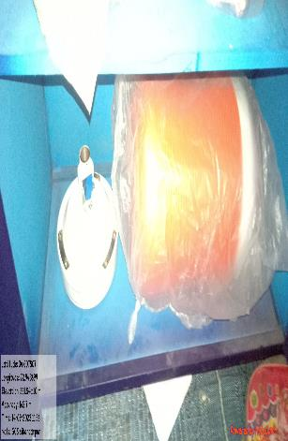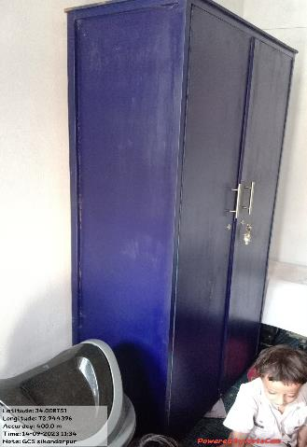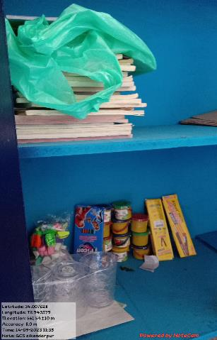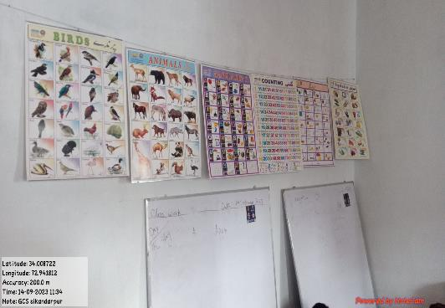

Figure 15: Water cooler provided to GCS

Figure 14: Learning provided to GCS

Figure 13:A Cupboard is provided to GCS

Figure# 12: View of Girls Community School

Figure# 11: View of Girls Community School

|  |
| --- |
| *Pictures* |

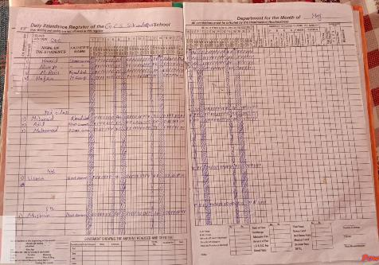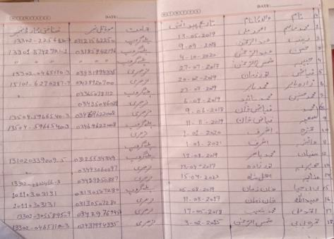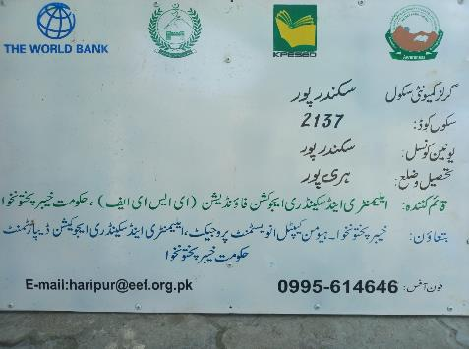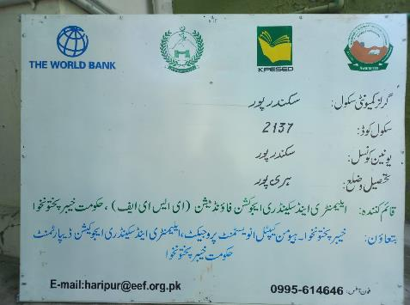**GCS Dairy Sikandarpur-District Haripur; Dated: Sep 14, 2023**

Figure 19: Attendance register being maintained at GCS

Figure 18: Admission/withdrawal register maintained at GCS

Figure 17: View of provided Signboard to GCS

Figure 16: View of provided Signboard to GCS

|  |  |  |  |  |  |
| --- | --- | --- | --- | --- | --- |
| Total Learners Registered | Local Learners | Afghan Refugees | Withdrawal | Present at the time of visit | No. Of Facilitators |
| 43 | 36 | 07 | 00 | 37 | 00 |

**Key Findings:**

* GCS Dairy Sikandarpur situated in Tehsil Haripur of District Haripur, Union Council Sikandarpur.
* GCS is established at rented place, managed by facilitator.
* The GCS is operational since April 2023.
* The GCS is functioning during the morning shift from 07:30 am to 12:30 pm.
* Supplies of various items held to the visited GCS, including a signboard, teacher’s chairs, Matts, whiteboard, notebooks, stationary, teaching and learning material, water cooler, steel cupboard.
* The place where the GCS is established is comprised of 2 rooms; one is currently utilized as a GCS while another one could be used for future expansion.
* During the visit, the Girls Community School (GCS) was in the process of being relocated. As per the facilitator, the GCS had recently been moved to its present location the day prior to the visit. Prior to this move, the GCS was housed within the facilitator's residence; however, due to space constraints, the decision was made to relocate. During the visit, it was noted that certain supplied items such as signboards and cupboards had not yet been shifted and verified duly.
* Despite under shifting the GCS was fully functional. The facilitator ensured to not interrupt the operations of the GCS.
* The GCs was observed functional, having 43 learners (22 Girls and 21 Boys) registered; Out of them, 07 learners are Afghan Refugee (03-Girls, 04-Boys), while 36 Learners (19-Girls, 17-Boys) are local.
* The age range of the learners in the center was between 3.5 and 10 years.
* The center operates as a multigrade establishment, currently accommodating students from Prep, and grades 1st, 2nd, and 3rd.
* Female facilitator, Miss. Maria Fazoon was present in the center. She is a local community member, done M.Sc. International Relations (IR) (fulfilling the minimum qualification criteria of B.A). Facilitator posses 8 years of professional teaching experience.
* Miss. Maria Fazoon having service agreement with ESEF. She also confirmed that stipend for the months of Apr, May and June is received.
* Inside the center the required facilities like washrooms, drinking water electricity and boundary wall was available.
* For the community support and smooth operations of the center Village Education Committee (VEC) formation has held, total 07 members are a part of the committee, including 01 female & 06 male community members. Since the formation of VEC and establishment of GCS, only for once the committee meeting is held.
* During the visit, the facilitator also mentioned that no government primary school exist inside or nearby the village, but Government Primary school is situated at approx. 03 K.M away outside the village Dairy Sikandarpur.
* As of the visit date, the facilitator has not received any training on GCS scope. However, she was communicated that in the month of Oct or Nov 2023 the training will be scheduled.
* 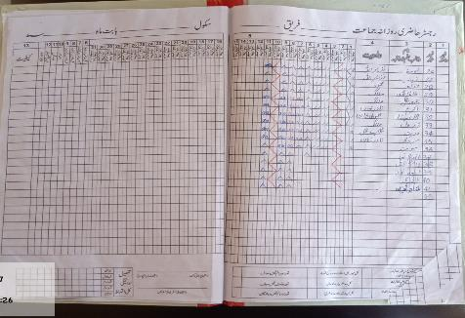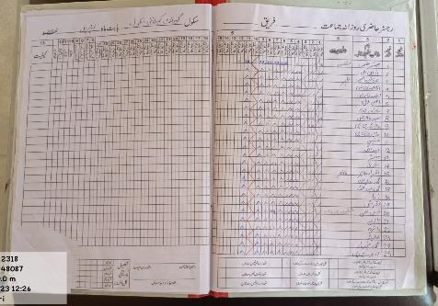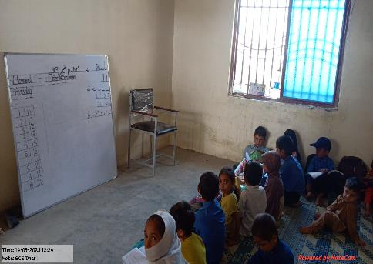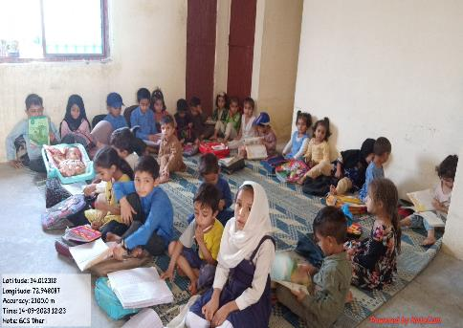Facilitator also shared that ESEF district office staff visit the GCS on monthly basis. The last visit held by them was focused on the teaching observation.

Figure 23: Attendance register being maintained at GCS

Figure 22: Attendance register being maintained at GCS

Figure 20: View of learners at GCS, Dairy Sikandarpur

Figure 21: View of learners at GCS, Dairy Sikandarpur

|  |
| --- |
| *Pictures* |